**Arrays**



An array is an indexed collection of fixed number of homogenous data elements. The main advantage of array’s is we can represent huge number of values by using single variable so that readability of code will be improved. But the main disadvantage of array’s is fixed in size that is once we can create an array there is no chance of increasing or decreasing the size based on our requirement. Hence to use array’s concept compulsory we should know the size in advance which maynot possible always.



**Array Declaration**

1-D array declaration

int[] x; //valid and recommended name is clearly separated from type

int []x; //valid

int x[]; //valid



*int[6] x; //invalid – At the time of declaration we can’t specify size

int[] x; //valid

At the time of declaration we can’t specify the size. Otherwise we will get Compile time error.

**2-D Array**

int[][] x; //valid

int [][]x; //valid

int x[][]; //valid

int[] []x; //valid

int[] x[]; //valid

int []x[]; //valid

**Which of the following are valid?**

int[] a,b; 🡪 **a dim is 1 and b dim is 1**

int[] a[],b; 🡪 **a dim is 2 , b dim is 1**

int[] a[],b[] 🡪 **a dim 2, b dim is 2**

int[] []a,b; 🡪 **a dim 2, b dim is 2**

int[] []a,b[] 🡪 **a dim is 2, b dim is 3**

int[] []a,[]b 🡪 **Compile time error IF you want to declare dim before variable then it is only applicable for first variable**

**int[] []a,[]b,[]c; 🡪 Invalid CE**

**3-D Array**

int[][][] a;

int [][][]a;

int a[][][];

int[] [][]a;

int[] a[][];

int[] []a[];

int[][] []a;

int[][] a[];

int [][]a[];

int [][]a[];

int []a[][];

All above are valid

Every array in java is object only hence we can create arrays by using new operator

Eg int[] a = new int[3];

Sop(a.getClass().getName()); //[I – These classes are part of java language not available to the programmer level.

For every array type corresponding classes are available and these classes are part of java language not available to the programmer level.

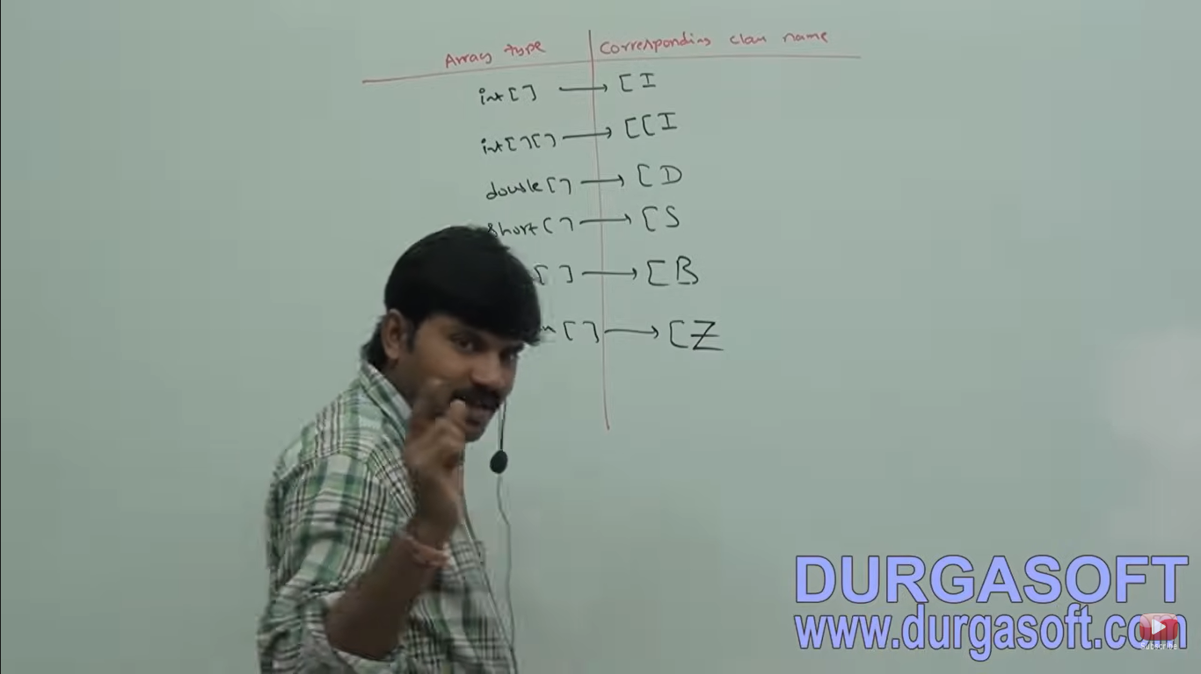

1. At the time of creation compulsory we should specify the size otherwise we will get compile time error.

int[] x = new int[]; //invalid

int[] x = new int[6]; //valid

int[] x = new int[0] ; //valid

It is legal to have an array with size 0 in java.

int[] x = new 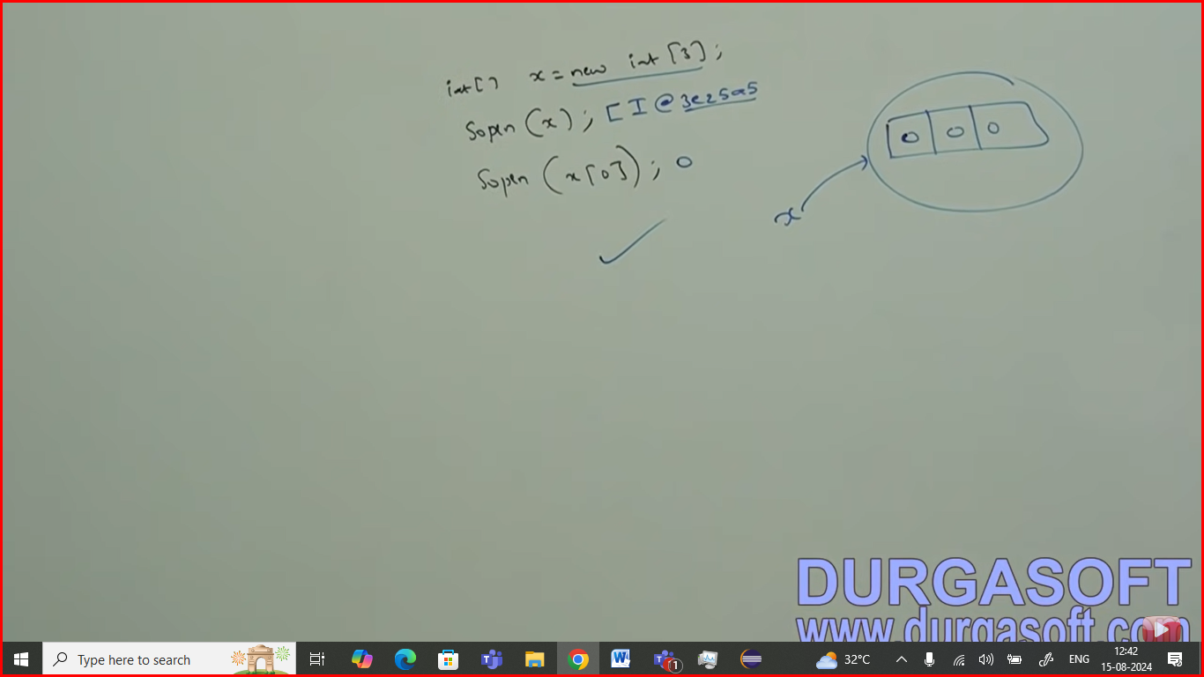time valid but we will get Runtime exception: Negative array size exception

int x = new int[‘a’]; //valid length is 97

To specify array size the allowed data types are:

Byte, short char, int



If we are trying to specify any other type then we will get compile time error.



Even in the first case we may get runtime exception If sufficient heap memory not available .

**2-D Array creation**

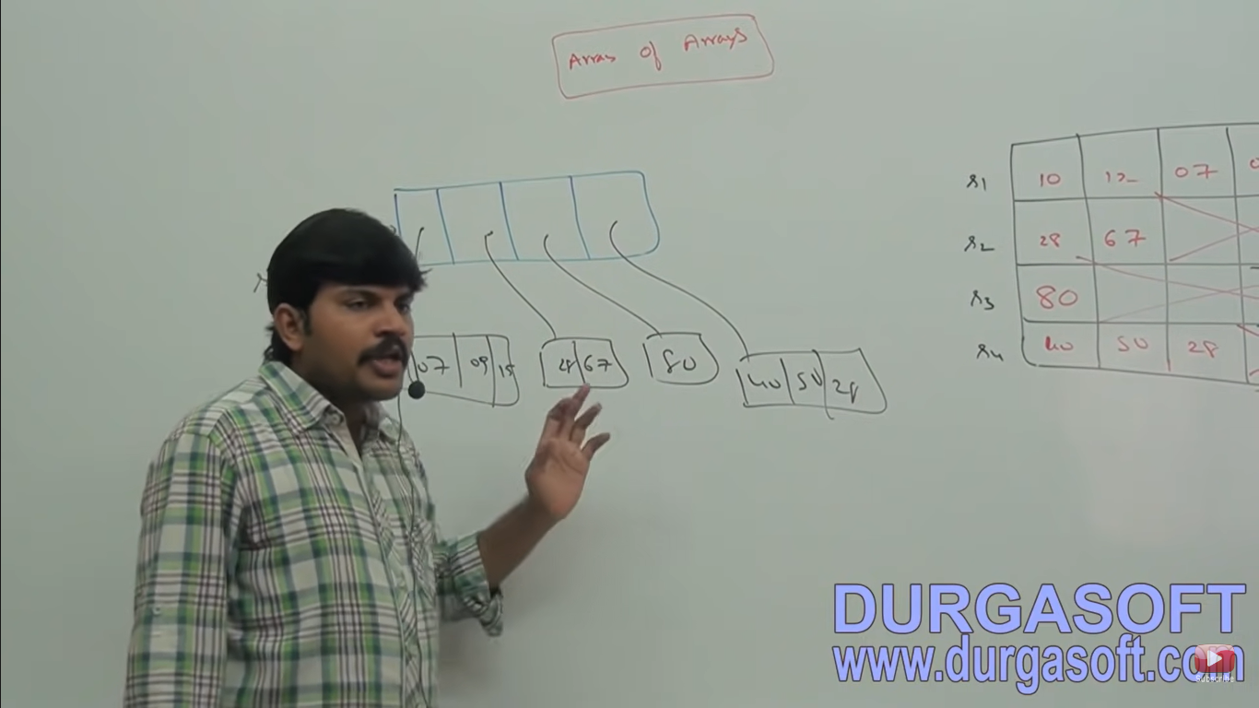

In java 2-D array not implemented by using matrix style Sun people followed Array of Array approach for multi dimensional array creation. The main advantage of this approach is memory utilization will be improved.

Ex1:

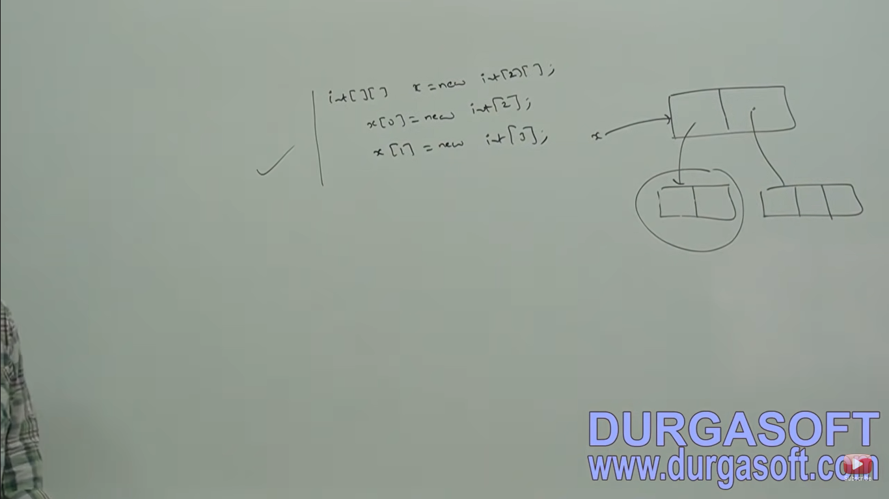

3-D Array

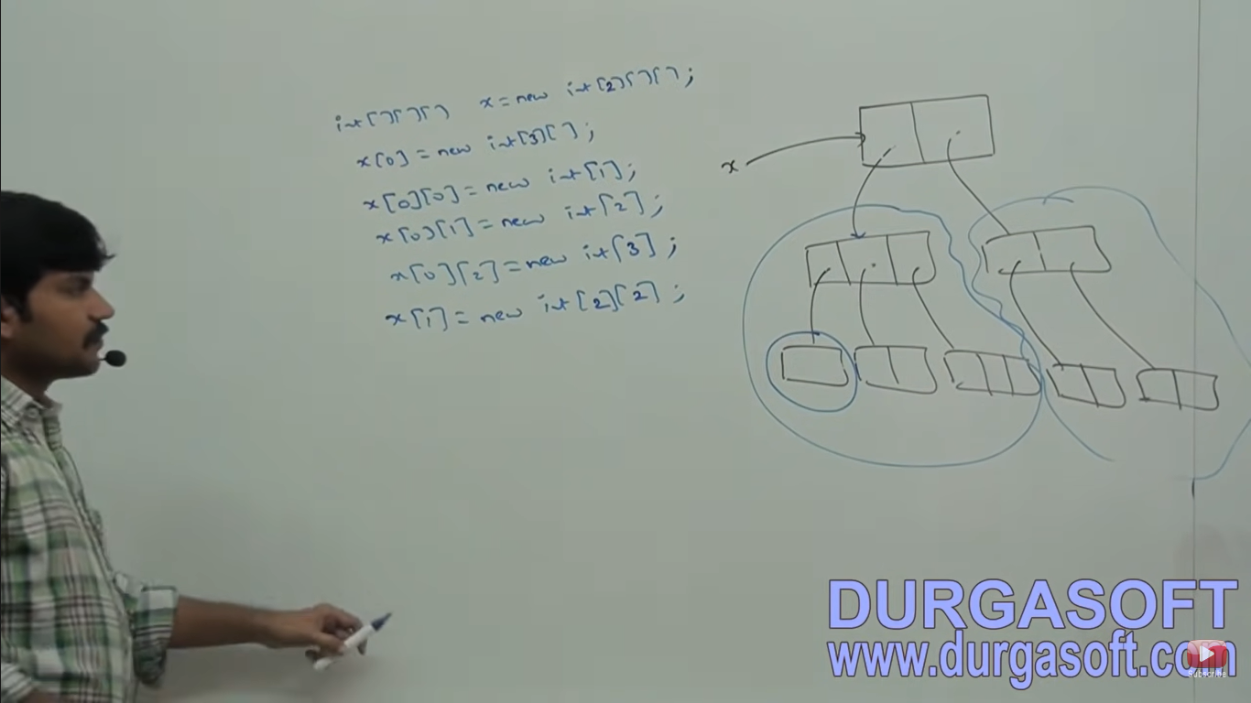

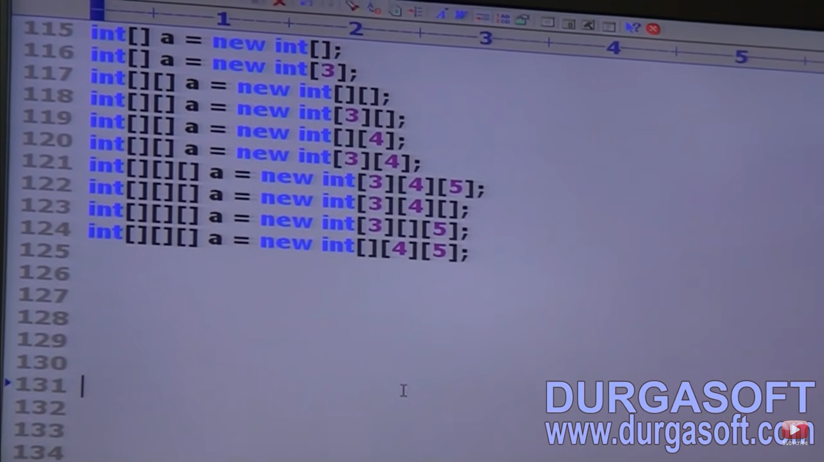

1 – Invalid

2 – Valid

3 – Invalid base size need to specify

4 – valid base size is specified

5 – invalid

6 – valid

7 – valid

8 – valid

9 – invalid without specifying second dim we can’t third dim

10 – invalid base size not specified



Every array element by default initialized with default values.

Whenever we are trying to print nay reference variable internally toString() method will be called which is implemented by default to return the string in the following form classname@hashcode_in_hexadecimalform.

int[][] x = new int[2][3];

sop(x); // [[I@3e25a5

sop(x[0]); // [I@19821f

sop(x[0][0]); //0

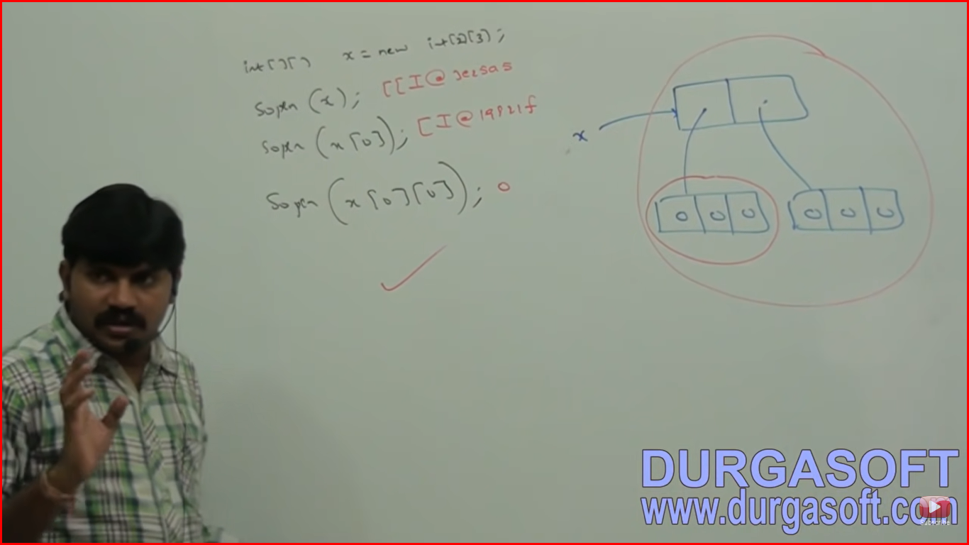

**Array Size in Java**

* **Array Size as int:** In Java, the size of an array is required to be of type int. This is because array indexing and the internal representation of arrays in the Java Virtual Machine (JVM) are based on int values. The maximum possible size of an array is limited by the maximum value of an int (2^31 - 1, or 2,147,483,647), which is more than sufficient for most practical purposes.
* **Why Not long?:** Allowing a long as the array size would complicate the internal implementation of arrays in Java. The int type is sufficient for addressing elements in arrays, given the JVM's design and the constraints of memory.

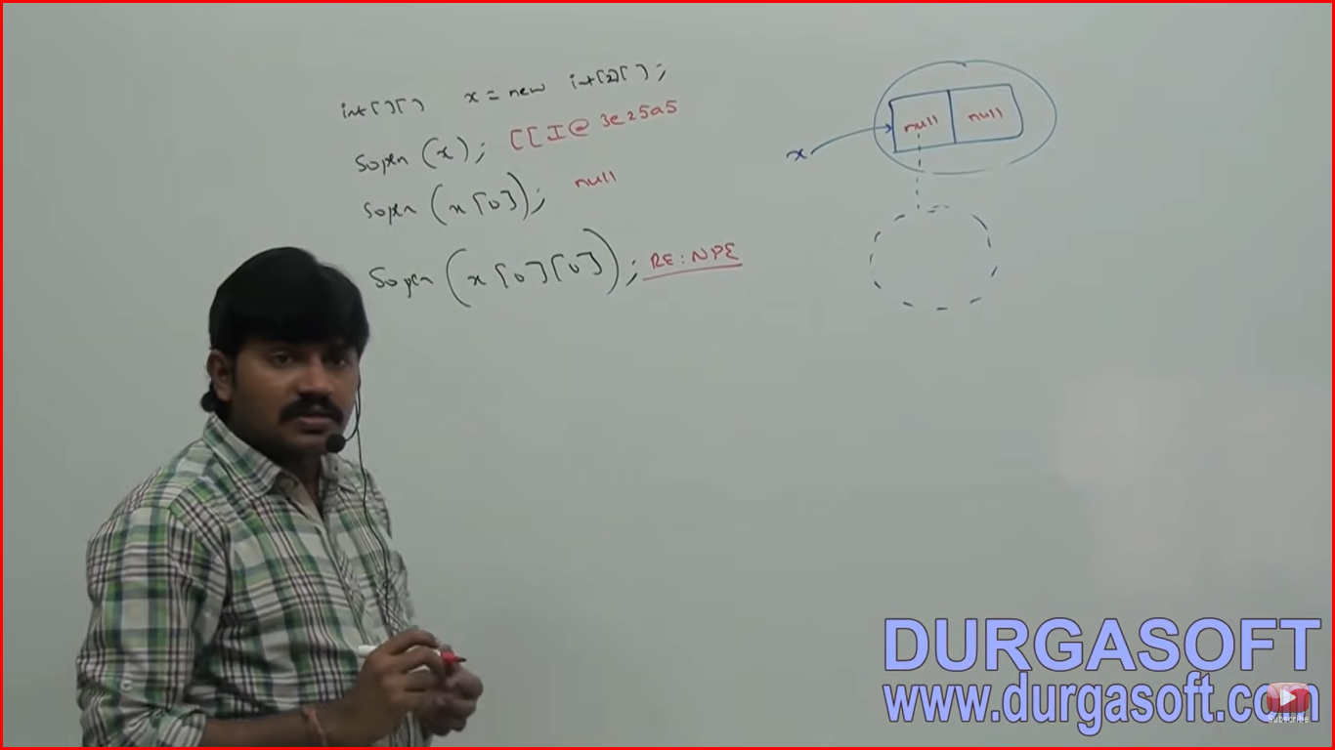

Once we create an array. Every array element by default initialized with default values, if we are not satisfied with default values then we can override these values with our customized values.

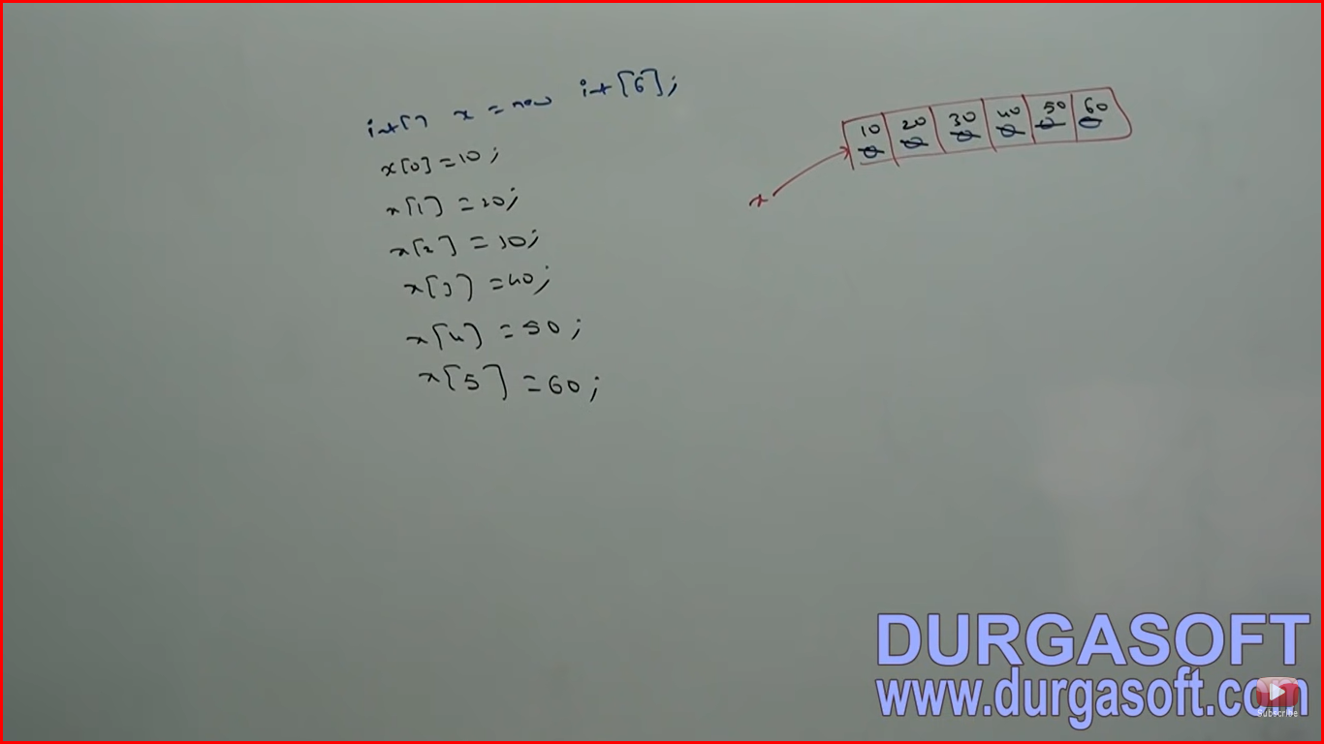

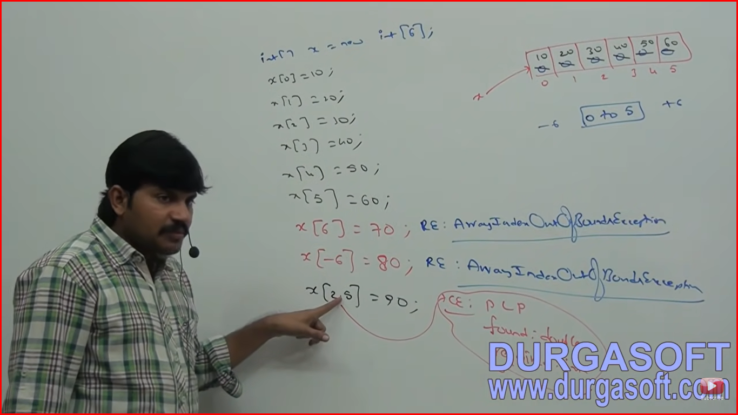

If we are trying to access array element with out of range index (either positive values or negative int value) then we will get run time exception saying “ArrayIndexOutOfBoundException”.

**Array Declaration, Creation, And Initialization in a Single Line**

We can declare create and initialize an array in a single line (shortcut representation)

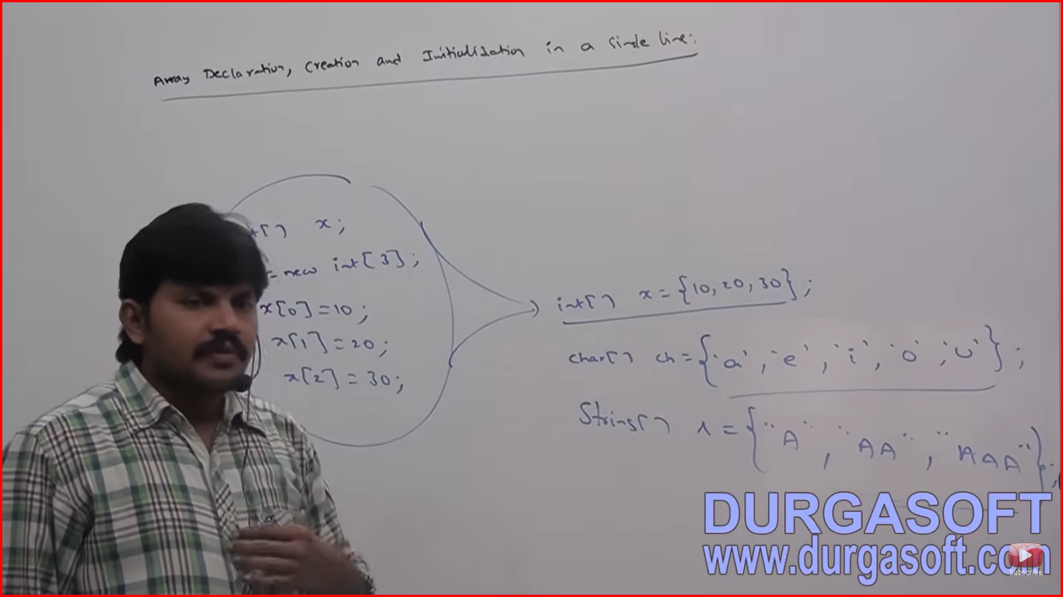

2-D Array

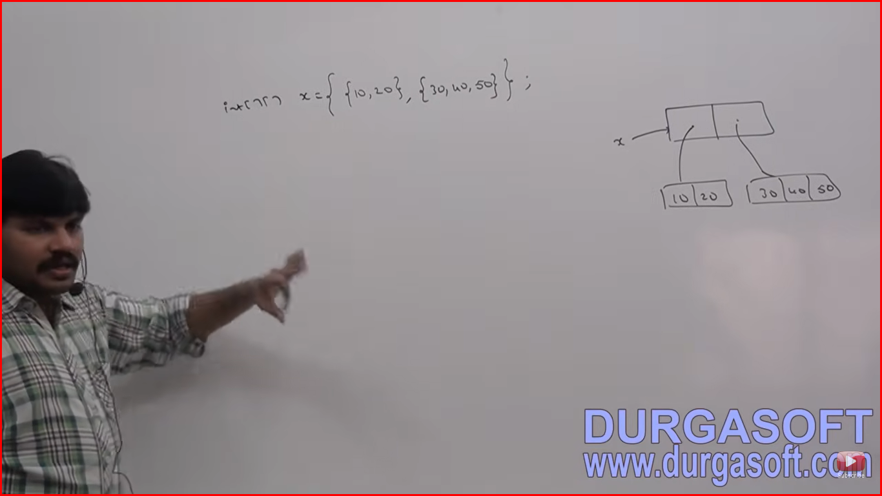

We can extend this shortcut for multidimensional array (2-D array) also

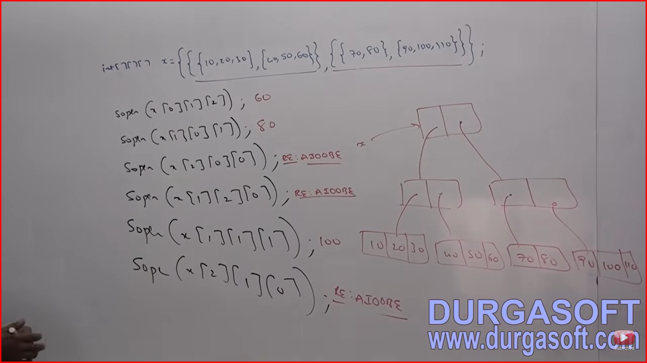

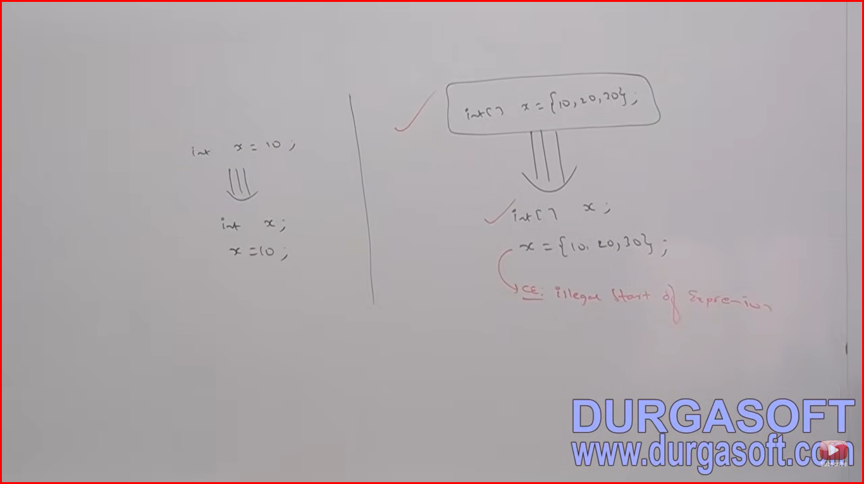

If we want to use this shortcut compulsory we should perform all activities in a single line.

If we are trying to divide into multiple lines then we will get compile time error.

**Length vs Length()**

Length is a final variable applicable for arrays. Length variable represents the size of the array

Ex:

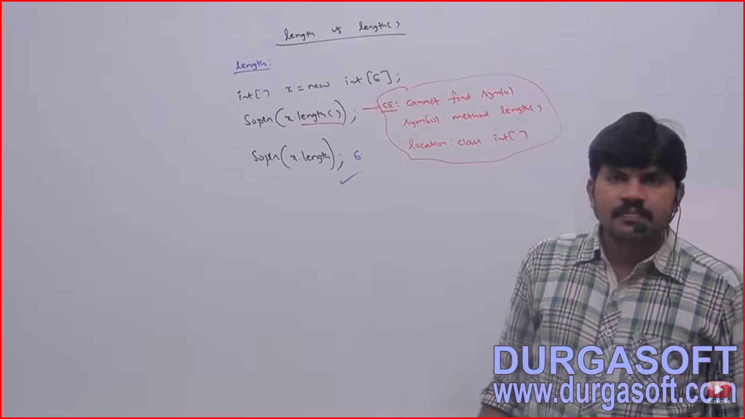

length() method is a final method applicable for String objects.

Length() method returns number of characters present in the String.

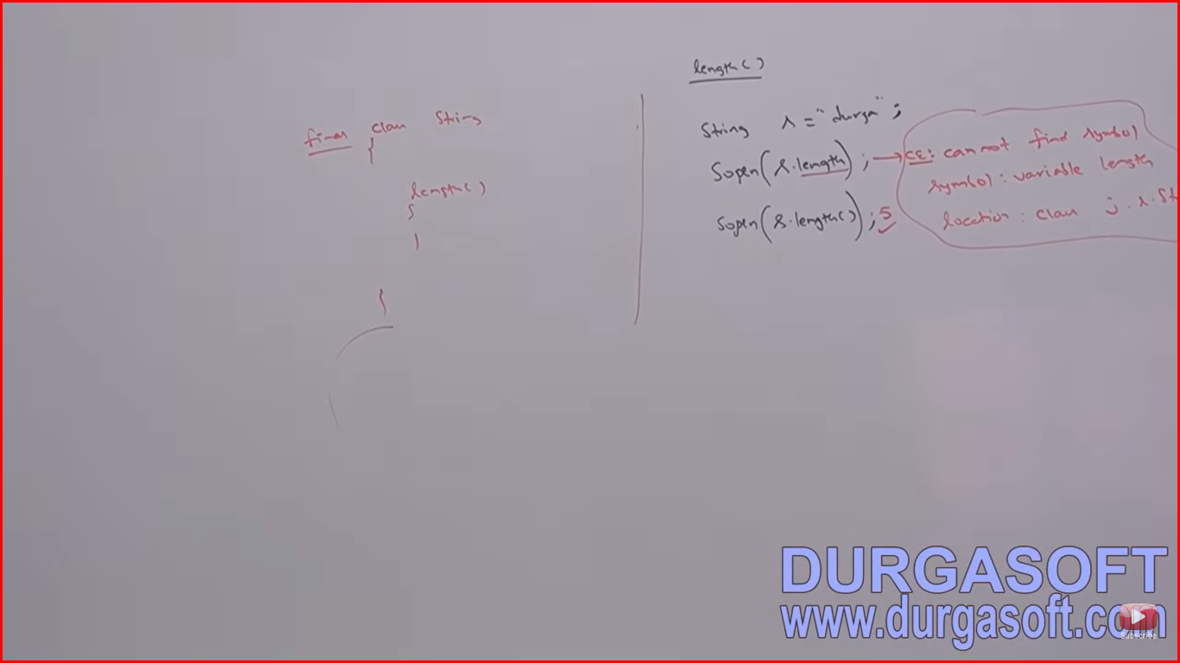

Note – length variable is applicable for Arrays but not for String objects. Whereas length() method applicable for String objects but not for Arrays.

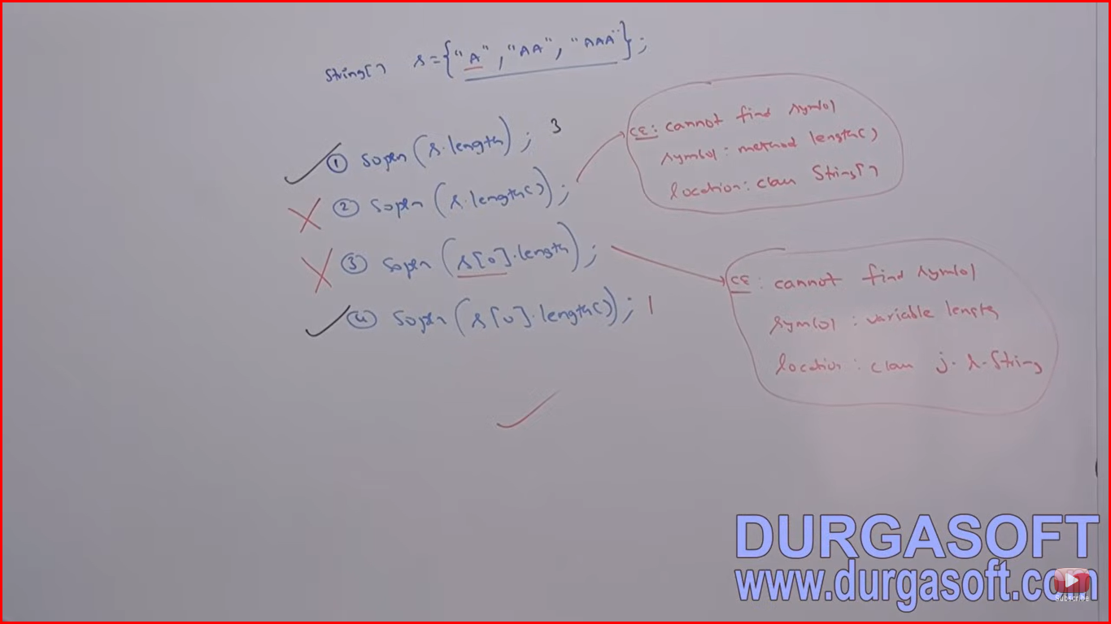

In multidimensional arrays length variable represents only base size but not total size.

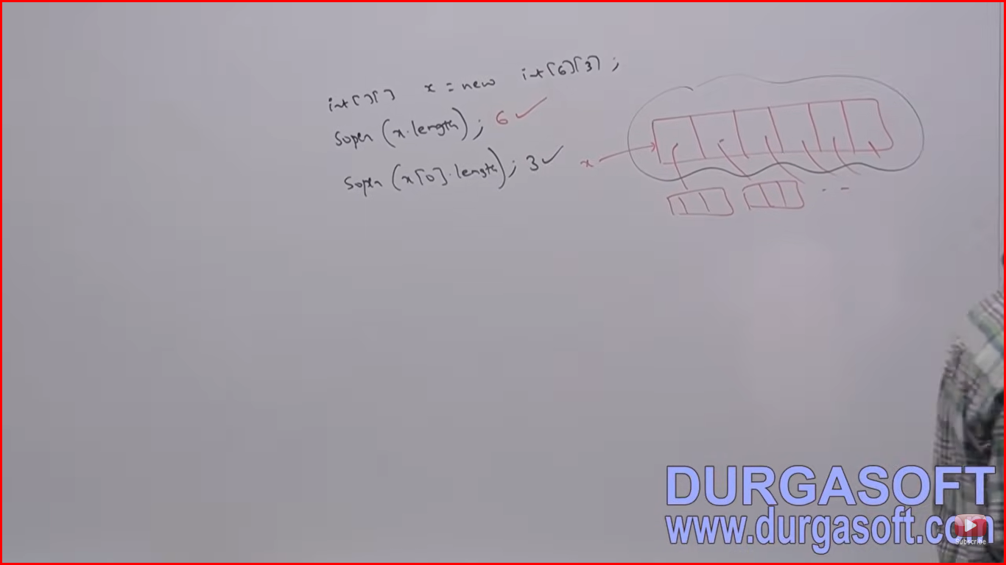

There is no direct way to find total length of multidimensional array. But indirectly we can find as follows:

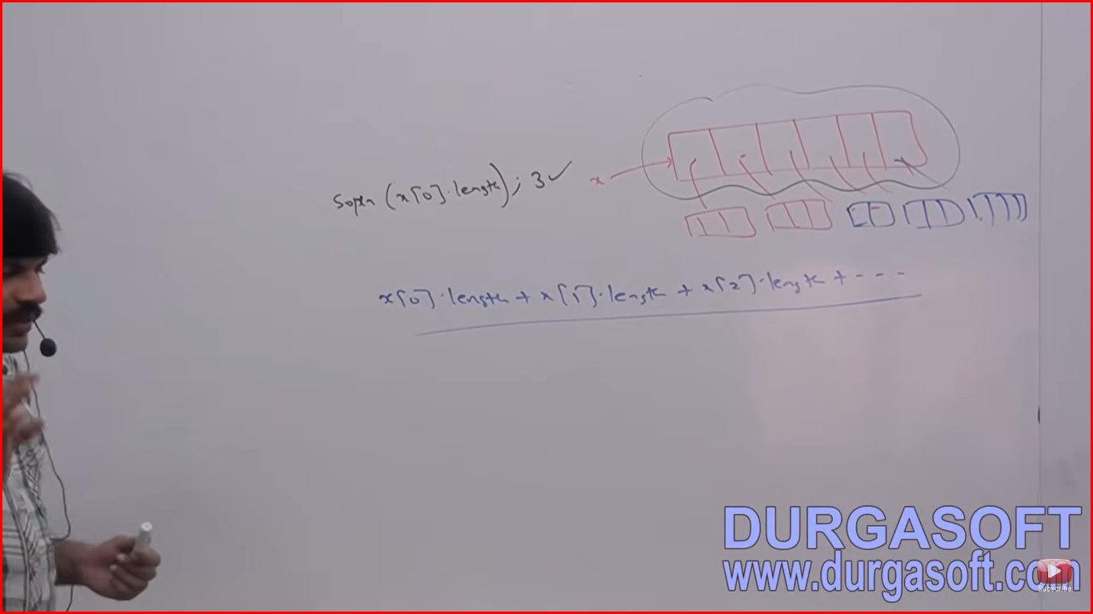

**Anonymous Arrays**

We can declare an array without name such type of nameless arrays are called anonymous arrays.

The main purpose of anonymous arrays is just for instant use (one time usage)

We can create anonymous arrays as follows:

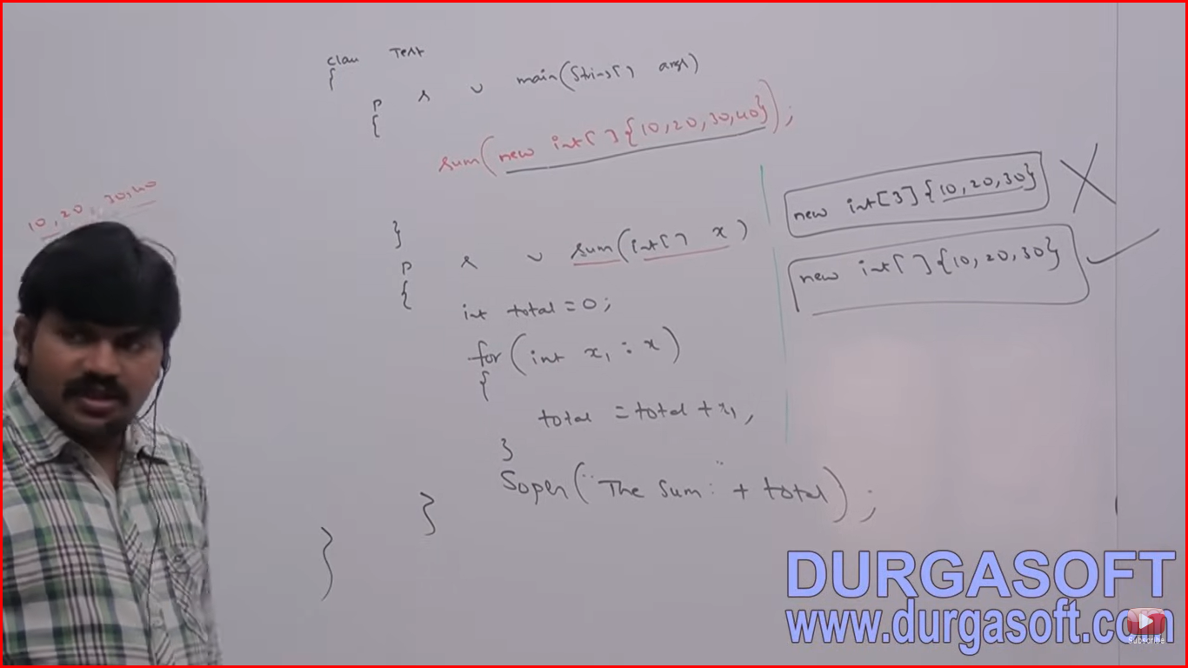

While creating anonymous arrays we can’t specify the size otherwise we will get compile time error.

We can create multi dimensional anonymous arrays also:

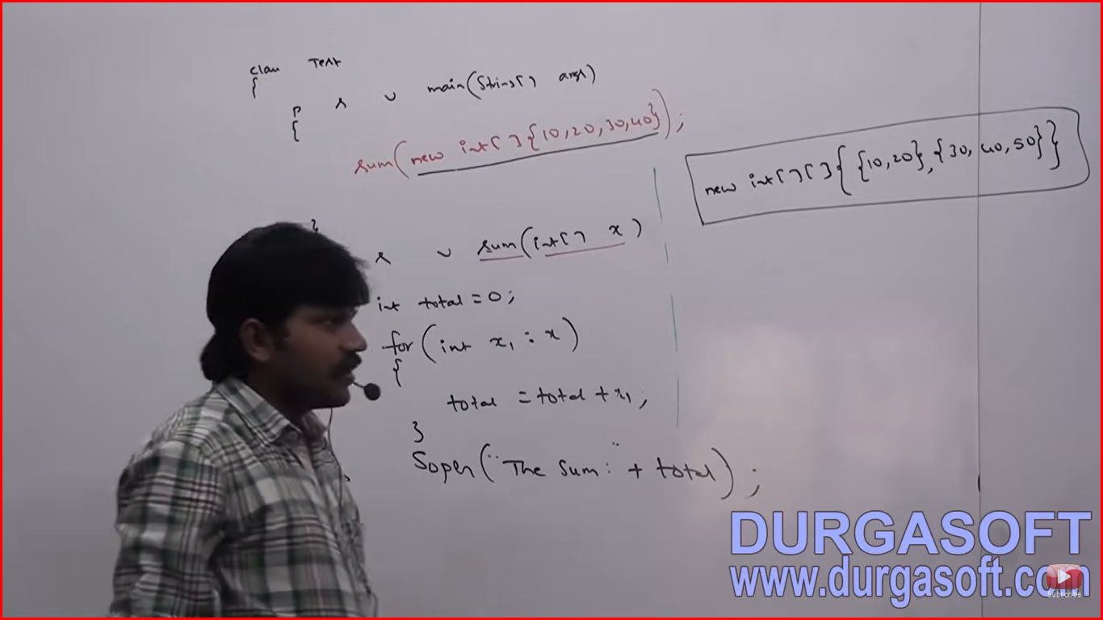

Based on our requirement we can give the name for anonymous array then it is no longer anonymous

int[] x = new int[] {10,20,30}; //valid

Just to call sum() method we require an array but after completing sum() method call we are not using that array anymore hence for this one time requirement anonymous array is the best choice.

**Elements Assignment**

Case 1: int[] x = new int[5];

x[0]=10;

x[1] =’a’;

byte b = 20;

x[2]=b;

short s=30;

x[3]=s;

x[4]=10l;//invalid

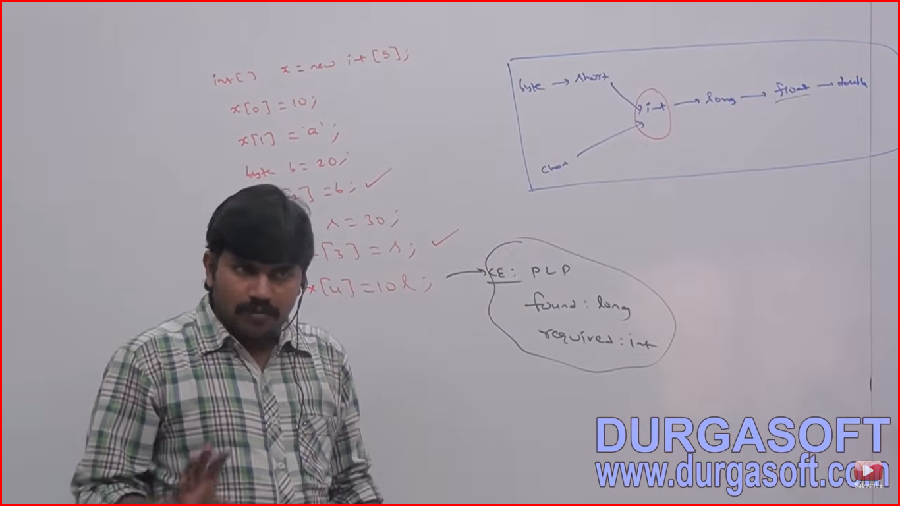

In the case of primitive type arrays as array elements we can provide any type which can be implicitly promoted to declared type. In the case of float type arrays the allowed data types are byte, short , char , int, long

**Case 2: Object Type Arrays**

Object[] a = new Object[10];

A[0] = new Object(); //valid

A[1] = new String(“durga”); //valid

A[2] = new Integer(10);

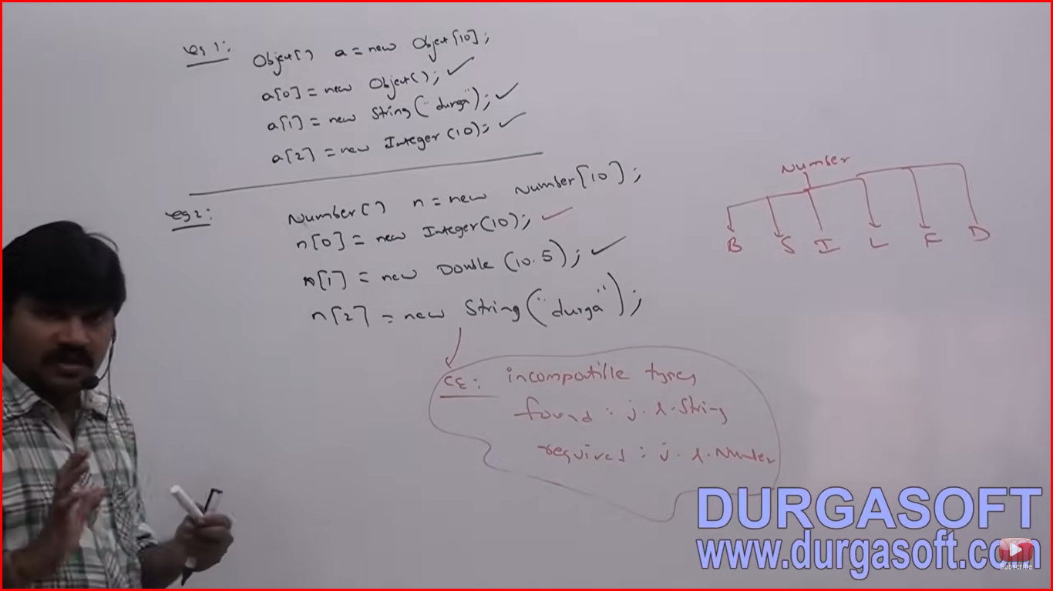

In the case of Object type arrays as array element we can provide declared type object or child class objects.

**Case 3: For Interface type arrays as array elements it’s implementation class objects are allowed**

Runnable[] r = new Runnable[10]; //Runnable type array object we can create, Interface type array object we can create but not array object.

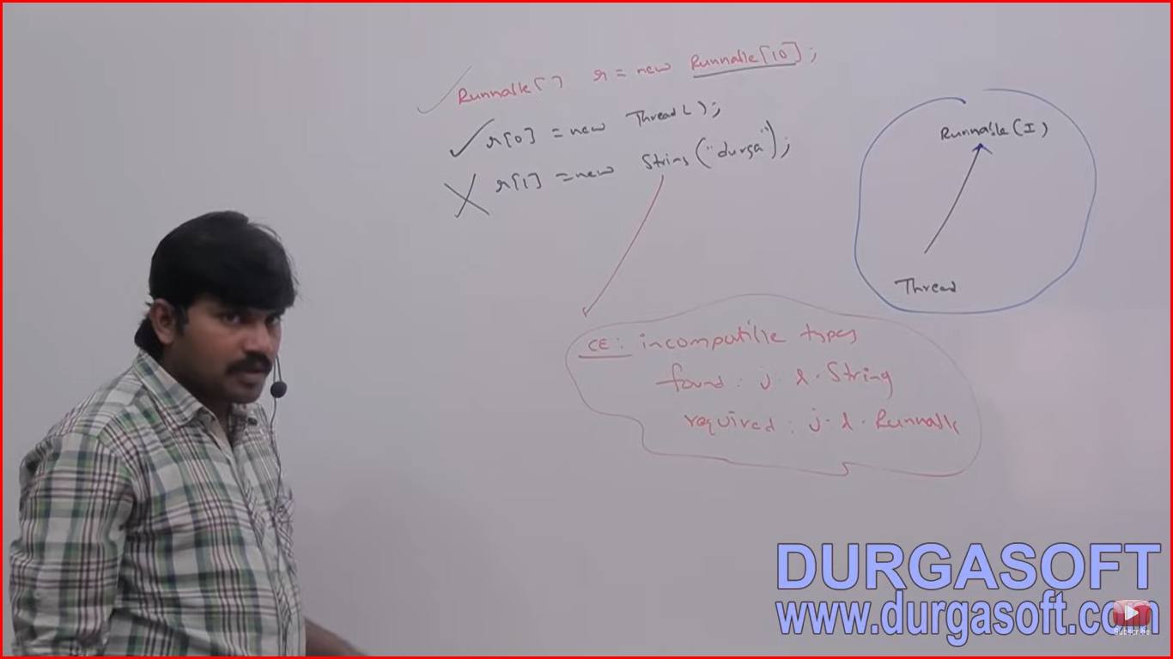

**Summary**

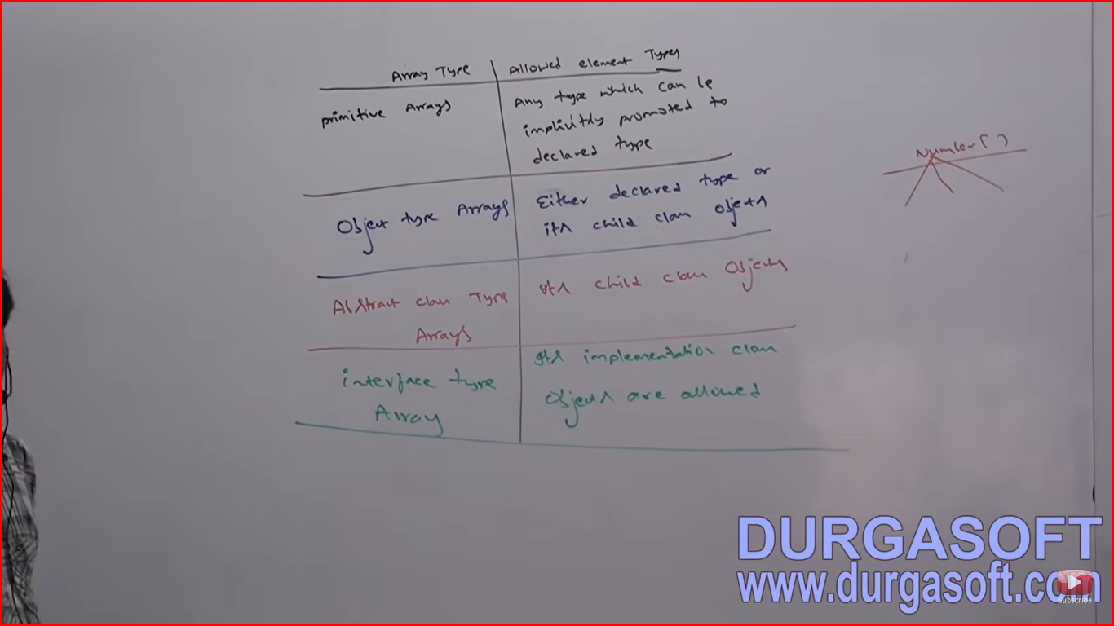

Case 1: Elements level promotions are not applicable at array level. For Eg:

Char a 🡪 Int a (Char element can be promoted to int type whereas char array cannot be promoted to int array

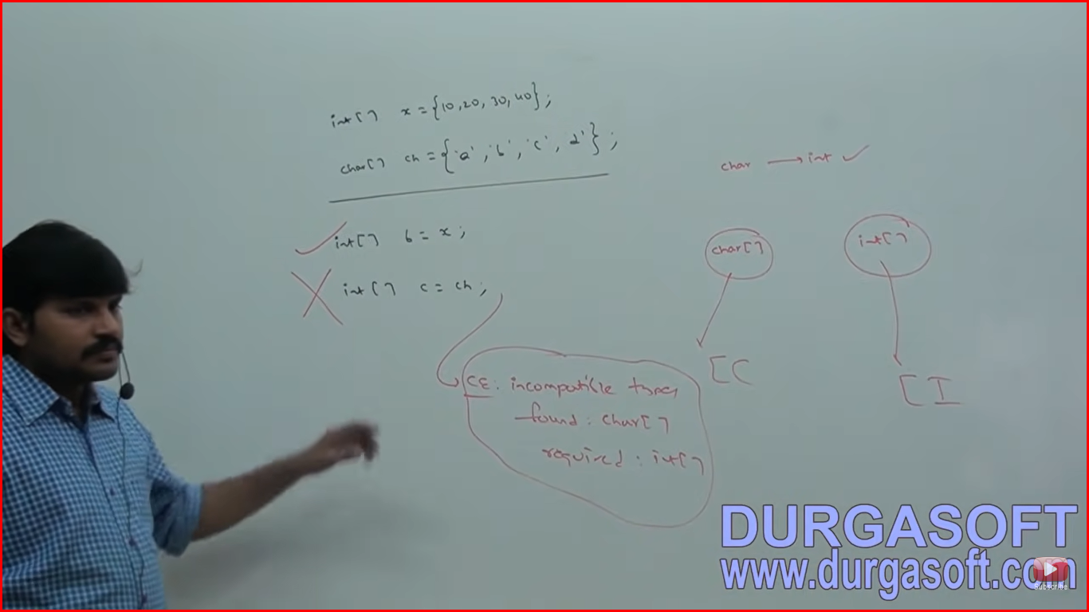

int x;

char x;

Which of the following promotions will be performed automatically?

Char -> int //valid

Char[] -> int[] //invlaid

Int->double //valid

Int[]->double[] //invalid

Float->int //invalid

Float[]->int[] //invalid

String->object //valid

String[]->Object[] //valid

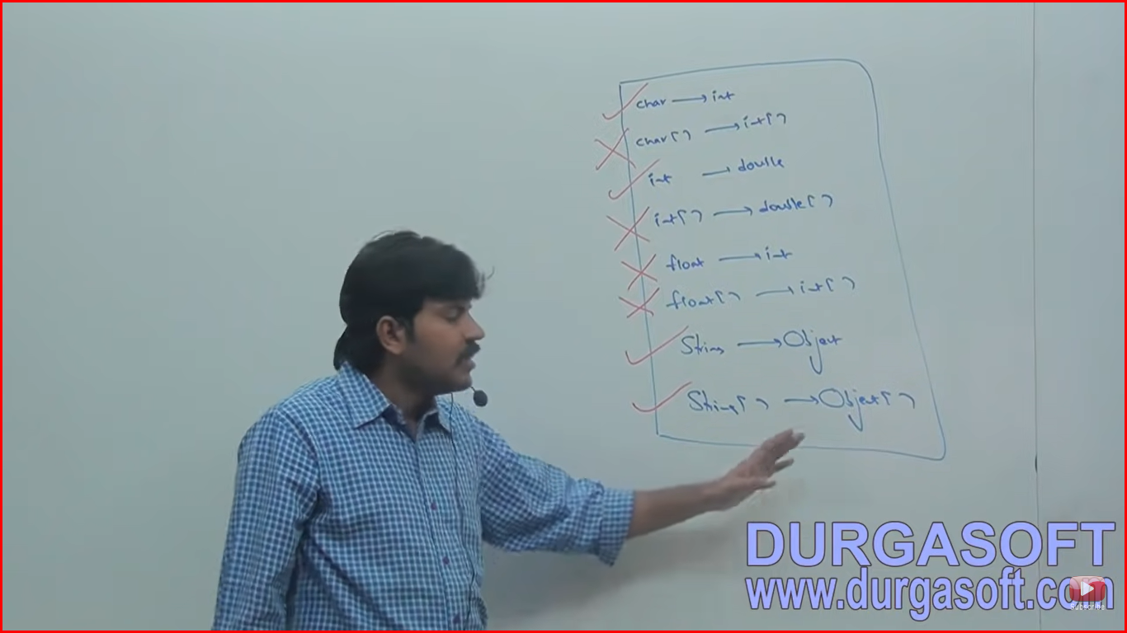

But in the case of object type arrays child class type array can be promoted to parent class type array

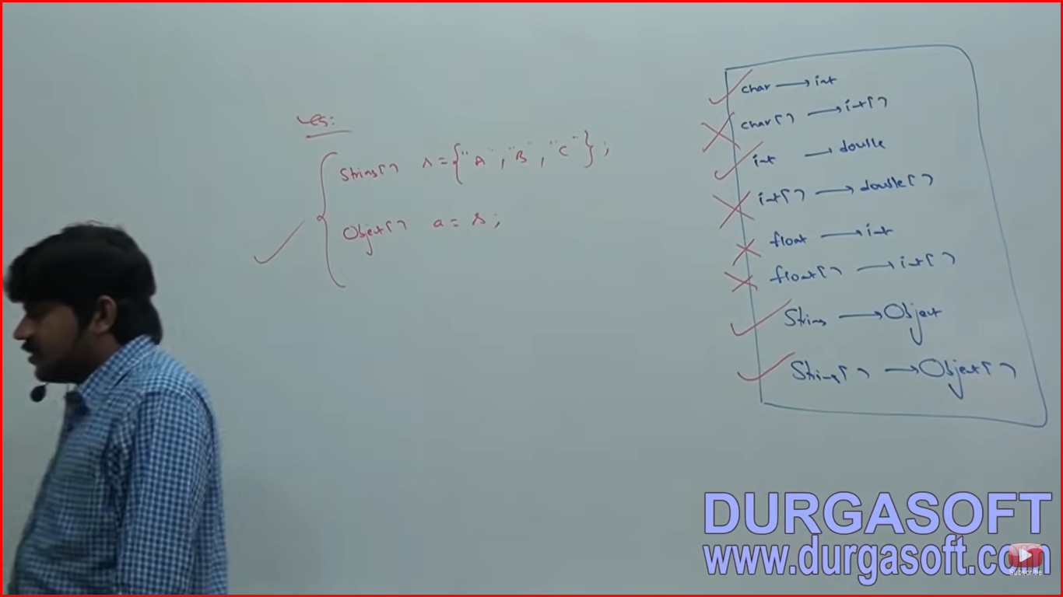

Case 2: Reference variable reassigning sizes are not required to match but both should be same type.

Whenever we are assigning one array to another array internal elements won’t be copied just reference variables will be reassigned.

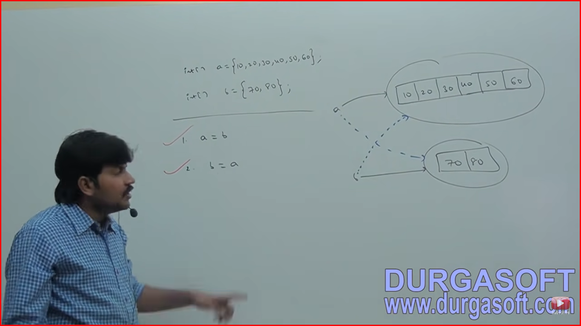

Case 3: Whenever we are assigning one array to another array the dimension must be matched. For eg in the place of one dimensional int array we should provide one dimensional array only. If we are trying to provide any other dimension then we will get compile time error.

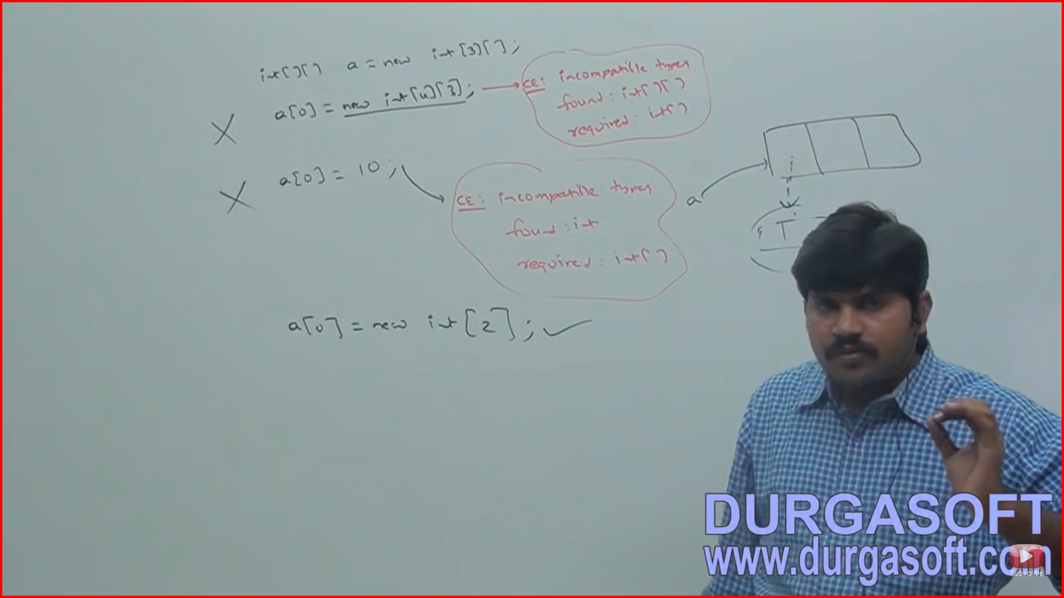

Whenever we assigning one array to another array both dimension and type must be matched but sizes are not required to match.

ArrayIndexOutOfBoundException

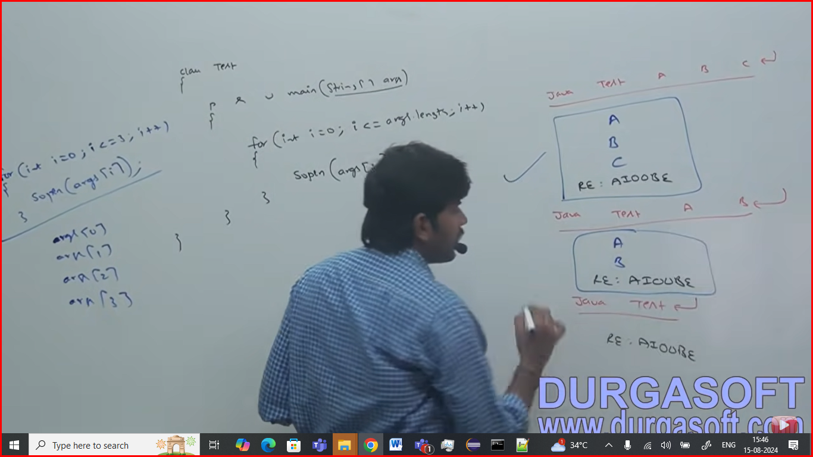

In all cases below we are getting X,Y,Z only:

